Министерство образования республики Беларусь

Учреждение образования

«БЕЛОРУССКИЙ ГОСУДАРСТВЕННЫЙ УНИВЕРСИТЕТ ИНФОРМАТИКИ И РАДИОЭЛЕКТРОНИКИ»

Контрольная работа №2

по дисциплине «Методы защиты информации»

Студент 4 курса

Группы № 493551

Рыбак Артем Владимирович

Минск, 2018

**Введение**

Контрольная работа № 2 подразумевает изучение и программную реализацию алгоритма стандарта цифровой подписи ГОСТ 3410.

Целью работы является создание и тестирование алгоритма цифровой подписи ГОСТ 3410 на языке высокого уровня.

**Блок-схема алгоритма**

Формирование цифровой подписи:

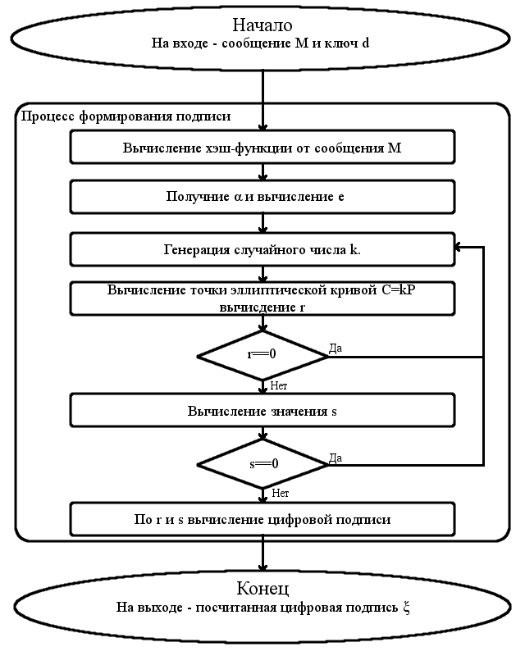

Проверка цифровой подписи:

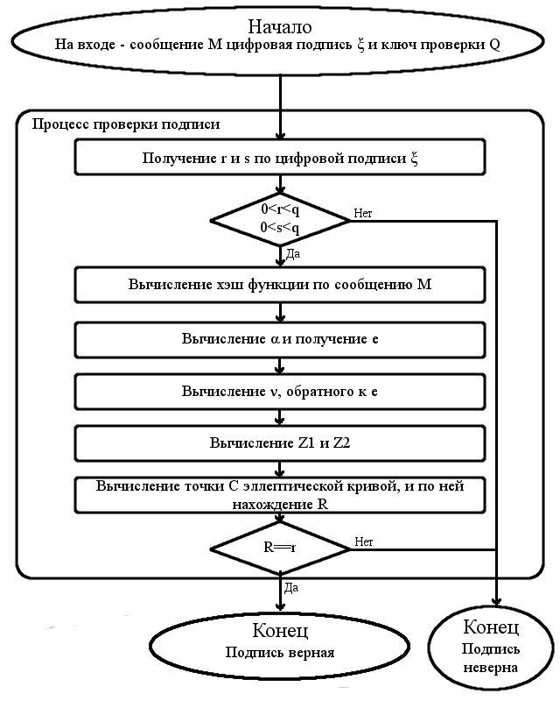

**Результаты ввода данных и исполнения программы**

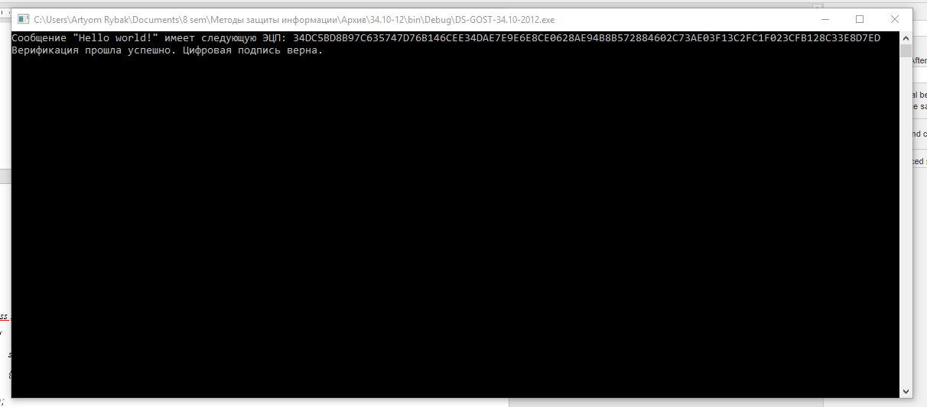

**Програмный код**

*class Program*

*{*

*static void Main(string[] args)*

*{*

*BigInteger p = new BigInteger("6277101735386680763835789423207666416083908700390324961279", 10);*

*BigInteger a = new BigInteger("-3", 10);*

*BigInteger b = new BigInteger("64210519e59c80e70fa7e9ab72243049feb8deecc146b9b1", 16);*

*byte[] xG = fromHexStringToByte("03188da80eb03090f67cbf20eb43a18800f4ff0afd82ff1012");*

*BigInteger n = new BigInteger("ffffffffffffffffffffffff99def836146bc9b1b4d22831", 16);*

*CDS DS = new CDS(p, a, b, n, xG);*

*BigInteger d = DS.genPrivateKey(192);*

*CECPoint Q = DS.genPublicKey(d);*

*CStribog hash = new CStribog(256);*

*/\**

*byte[] H = hash.GetHash(Encoding.Default.GetBytes("Message"));*

*string sign = DS.genDS(H, d);*

*byte[] H2 = hash.GetHash(Encoding.Default.GetBytes("message"));*

*string sign2 = DS.genDS(H2, d);*

*\*/*

*String path = "test.txt";*

*String message = readFile(path);*

*byte[] H = hash.GetHash(Encoding.Default.GetBytes(message));*

*string sign = DS.genDS(H, d);*

*Console.WriteLine("Сообщение \"{0}\" имеет следующую ЭЦП: {1}", message, sign);*

*path = "out.txt";*

*writeFile(path, sign);*

*path = "verify.txt";*

*String message2 = readFile(path);*

*byte[] H2 = hash.GetHash(Encoding.Default.GetBytes(message2));*

*path = "out.txt";*

*string signVer= readFile(path);*

*//string sign2 = DS.genDS(H2, d);*

*bool result = DS.verifDS(H2, signVer, Q);*

*if (result)*

*System.Console.WriteLine("Верификация прошла успешно. Цифровая подпись верна.");*

*else*

*System.Console.WriteLine("Верификация не прошла! Цифровая подпись не верна.");*

*System.Console.ReadLine();*

*}*

*private static byte[] fromHexStringToByte(string input)*

*{*

*byte[] data = new byte[input.Length / 2];*

*string HexByte = "";*

*for (int i = 0; i < data.Length; i++)*

*{*

*HexByte = input.Substring(i * 2, 2);*

*data[i] = Convert.ToByte(HexByte, 16);*

*}*

*return data;*

*}*

*private static string readFile(string path)*

*{*

*string text = System.IO.File.ReadAllText(path);*

*return (text);*

*}*

*private static void writeFile(string path, string text)*

*{*

*System.IO.File.WriteAllText(path, text);*

*}*

*}*

*class CStribog*

*{*

*//бинарная матрица A, используется для функции перемножения (L-преобразование).*

*private ulong[] A =*

*{*

*0x8e20faa72ba0b470, 0x47107ddd9b505a38, 0xad08b0e0c3282d1c, 0xd8045870ef14980e,*

*0x6c022c38f90a4c07, 0x3601161cf205268d, 0x1b8e0b0e798c13c8, 0x83478b07b2468764,*

*0xa011d380818e8f40, 0x5086e740ce47c920, 0x2843fd2067adea10, 0x14aff010bdd87508,*

*0x0ad97808d06cb404, 0x05e23c0468365a02, 0x8c711e02341b2d01, 0x46b60f011a83988e,*

*0x90dab52a387ae76f, 0x486dd4151c3dfdb9, 0x24b86a840e90f0d2, 0x125c354207487869,*

*0x092e94218d243cba, 0x8a174a9ec8121e5d, 0x4585254f64090fa0, 0xaccc9ca9328a8950,*

*0x9d4df05d5f661451, 0xc0a878a0a1330aa6, 0x60543c50de970553, 0x302a1e286fc58ca7,*

*0x18150f14b9ec46dd, 0x0c84890ad27623e0, 0x0642ca05693b9f70, 0x0321658cba93c138,*

*0x86275df09ce8aaa8, 0x439da0784e745554, 0xafc0503c273aa42a, 0xd960281e9d1d5215,*

*0xe230140fc0802984, 0x71180a8960409a42, 0xb60c05ca30204d21, 0x5b068c651810a89e,*

*0x456c34887a3805b9, 0xac361a443d1c8cd2, 0x561b0d22900e4669, 0x2b838811480723ba,*

*0x9bcf4486248d9f5d, 0xc3e9224312c8c1a0, 0xeffa11af0964ee50, 0xf97d86d98a327728,*

*0xe4fa2054a80b329c, 0x727d102a548b194e, 0x39b008152acb8227, 0x9258048415eb419d,*

*0x492c024284fbaec0, 0xaa16012142f35760, 0x550b8e9e21f7a530, 0xa48b474f9ef5dc18,*

*0x70a6a56e2440598e, 0x3853dc371220a247, 0x1ca76e95091051ad, 0x0edd37c48a08a6d8,*

*0x07e095624504536c, 0x8d70c431ac02a736, 0xc83862965601dd1b, 0x641c314b2b8ee083*

*};*

*//таблица подстановок, используется для функции подстановки (S-преобразование).*

*private byte[] Sbox=*

*{*

*0xFC, 0xEE, 0xDD, 0x11, 0xCF, 0x6E, 0x31, 0x16, 0xFB, 0xC4, 0xFA, 0xDA, 0x23, 0xC5, 0x04, 0x4D,*

*0xE9, 0x77, 0xF0, 0xDB, 0x93, 0x2E, 0x99, 0xBA, 0x17, 0x36, 0xF1, 0xBB, 0x14, 0xCD, 0x5F, 0xC1,*

*0xF9, 0x18, 0x65, 0x5A, 0xE2, 0x5C, 0xEF, 0x21, 0x81, 0x1C, 0x3C, 0x42, 0x8B, 0x01, 0x8E, 0x4F,*

*0x05, 0x84, 0x02, 0xAE, 0xE3, 0x6A, 0x8F, 0xA0, 0x06, 0x0B, 0xED, 0x98, 0x7F, 0xD4, 0xD3, 0x1F,*

*0xEB, 0x34, 0x2C, 0x51, 0xEA, 0xC8, 0x48, 0xAB, 0xF2, 0x2A, 0x68, 0xA2, 0xFD, 0x3A, 0xCE, 0xCC,*

*0xB5, 0x70, 0x0E, 0x56, 0x08, 0x0C, 0x76, 0x12, 0xBF, 0x72, 0x13, 0x47, 0x9C, 0xB7, 0x5D, 0x87,*

*0x15, 0xA1, 0x96, 0x29, 0x10, 0x7B, 0x9A, 0xC7, 0xF3, 0x91, 0x78, 0x6F, 0x9D, 0x9E, 0xB2, 0xB1,*

*0x32, 0x75, 0x19, 0x3D, 0xFF, 0x35, 0x8A, 0x7E, 0x6D, 0x54, 0xC6, 0x80, 0xC3, 0xBD, 0x0D, 0x57,*

*0xDF, 0xF5, 0x24, 0xA9, 0x3E, 0xA8, 0x43, 0xC9, 0xD7, 0x79, 0xD6, 0xF6, 0x7C, 0x22, 0xB9, 0x03,*

*0xE0, 0x0F, 0xEC, 0xDE, 0x7A, 0x94, 0xB0, 0xBC, 0xDC, 0xE8, 0x28, 0x50, 0x4E, 0x33, 0x0A, 0x4A,*

*0xA7, 0x97, 0x60, 0x73, 0x1E, 0x00, 0x62, 0x44, 0x1A, 0xB8, 0x38, 0x82, 0x64, 0x9F, 0x26, 0x41,*

*0xAD, 0x45, 0x46, 0x92, 0x27, 0x5E, 0x55, 0x2F, 0x8C, 0xA3, 0xA5, 0x7D, 0x69, 0xD5, 0x95, 0x3B,*

*0x07, 0x58, 0xB3, 0x40, 0x86, 0xAC, 0x1D, 0xF7, 0x30, 0x37, 0x6B, 0xE4, 0x88, 0xD9, 0xE7, 0x89,*

*0xE1, 0x1B, 0x83, 0x49, 0x4C, 0x3F, 0xF8, 0xFE, 0x8D, 0x53, 0xAA, 0x90, 0xCA, 0xD8, 0x85, 0x61,*

*0x20, 0x71, 0x67, 0xA4, 0x2D, 0x2B, 0x09, 0x5B, 0xCB, 0x9B, 0x25, 0xD0, 0xBE, 0xE5, 0x6C, 0x52,*

*0x59, 0xA6, 0x74, 0xD2, 0xE6, 0xF4, 0xB4, 0xC0, 0xD1, 0x66, 0xAF, 0xC2, 0x39, 0x4B, 0x63, 0xB6*

*};*

*//таблица перестановок, используется для функции перестановки (P-преобразование).*

*private byte[] Tau=*

*{*

*0, 8, 16, 24, 32, 40, 48, 56,*

*1, 9, 17, 25, 33, 41, 49, 57,*

*2, 10, 18, 26, 34, 42, 50, 58,*

*3, 11, 19, 27, 35, 43, 51, 59,*

*4, 12, 20, 28, 36, 44, 52, 60,*

*5, 13, 21, 29, 37, 45, 53, 61,*

*6, 14, 22, 30, 38, 46, 54, 62,*

*7, 15, 23, 31, 39, 47, 55, 63*

*};*

*//константный набор значений, для формирования временного ключа.*

*private byte[][] C =*

*{*

*new byte[64]*

*{*

*0xb1,0x08,0x5b,0xda,0x1e,0xca,0xda,0xe9,0xeb,0xcb,0x2f,0x81,0xc0,0x65,0x7c,0x1f,*

*0x2f,0x6a,0x76,0x43,0x2e,0x45,0xd0,0x16,0x71,0x4e,0xb8,0x8d,0x75,0x85,0xc4,0xfc,*

*0x4b,0x7c,0xe0,0x91,0x92,0x67,0x69,0x01,0xa2,0x42,0x2a,0x08,0xa4,0x60,0xd3,0x15,*

*0x05,0x76,0x74,0x36,0xcc,0x74,0x4d,0x23,0xdd,0x80,0x65,0x59,0xf2,0xa6,0x45,0x07*

*},*

*new byte[64]*

*{*

*0x6f,0xa3,0xb5,0x8a,0xa9,0x9d,0x2f,0x1a,0x4f,0xe3,0x9d,0x46,0x0f,0x70,0xb5,0xd7,*

*0xf3,0xfe,0xea,0x72,0x0a,0x23,0x2b,0x98,0x61,0xd5,0x5e,0x0f,0x16,0xb5,0x01,0x31,*

*0x9a,0xb5,0x17,0x6b,0x12,0xd6,0x99,0x58,0x5c,0xb5,0x61,0xc2,0xdb,0x0a,0xa7,0xca,*

*0x55,0xdd,0xa2,0x1b,0xd7,0xcb,0xcd,0x56,0xe6,0x79,0x04,0x70,0x21,0xb1,0x9b,0xb7*

*},*

*new byte[64]*

*{*

*0xf5,0x74,0xdc,0xac,0x2b,0xce,0x2f,0xc7,0x0a,0x39,0xfc,0x28,0x6a,0x3d,0x84,0x35,*

*0x06,0xf1,0x5e,0x5f,0x52,0x9c,0x1f,0x8b,0xf2,0xea,0x75,0x14,0xb1,0x29,0x7b,0x7b,*

*0xd3,0xe2,0x0f,0xe4,0x90,0x35,0x9e,0xb1,0xc1,0xc9,0x3a,0x37,0x60,0x62,0xdb,0x09,*

*0xc2,0xb6,0xf4,0x43,0x86,0x7a,0xdb,0x31,0x99,0x1e,0x96,0xf5,0x0a,0xba,0x0a,0xb2*

*},*

*new byte[64]*

*{*

*0xef,0x1f,0xdf,0xb3,0xe8,0x15,0x66,0xd2,0xf9,0x48,0xe1,0xa0,0x5d,0x71,0xe4,0xdd,*

*0x48,0x8e,0x85,0x7e,0x33,0x5c,0x3c,0x7d,0x9d,0x72,0x1c,0xad,0x68,0x5e,0x35,0x3f,*

*0xa9,0xd7,0x2c,0x82,0xed,0x03,0xd6,0x75,0xd8,0xb7,0x13,0x33,0x93,0x52,0x03,0xbe,*

*0x34,0x53,0xea,0xa1,0x93,0xe8,0x37,0xf1,0x22,0x0c,0xbe,0xbc,0x84,0xe3,0xd1,0x2e*

*},*

*new byte[64]*

*{*

*0x4b,0xea,0x6b,0xac,0xad,0x47,0x47,0x99,0x9a,0x3f,0x41,0x0c,0x6c,0xa9,0x23,0x63,*

*0x7f,0x15,0x1c,0x1f,0x16,0x86,0x10,0x4a,0x35,0x9e,0x35,0xd7,0x80,0x0f,0xff,0xbd,*

*0xbf,0xcd,0x17,0x47,0x25,0x3a,0xf5,0xa3,0xdf,0xff,0x00,0xb7,0x23,0x27,0x1a,0x16,*

*0x7a,0x56,0xa2,0x7e,0xa9,0xea,0x63,0xf5,0x60,0x17,0x58,0xfd,0x7c,0x6c,0xfe,0x57*

*},*

*new byte[64]*

*{*

*0xae,0x4f,0xae,0xae,0x1d,0x3a,0xd3,0xd9,0x6f,0xa4,0xc3,0x3b,0x7a,0x30,0x39,0xc0,*

*0x2d,0x66,0xc4,0xf9,0x51,0x42,0xa4,0x6c,0x18,0x7f,0x9a,0xb4,0x9a,0xf0,0x8e,0xc6,*

*0xcf,0xfa,0xa6,0xb7,0x1c,0x9a,0xb7,0xb4,0x0a,0xf2,0x1f,0x66,0xc2,0xbe,0xc6,0xb6,*

*0xbf,0x71,0xc5,0x72,0x36,0x90,0x4f,0x35,0xfa,0x68,0x40,0x7a,0x46,0x64,0x7d,0x6e*

*},*

*new byte[64]*

*{*

*0xf4,0xc7,0x0e,0x16,0xee,0xaa,0xc5,0xec,0x51,0xac,0x86,0xfe,0xbf,0x24,0x09,0x54,*

*0x39,0x9e,0xc6,0xc7,0xe6,0xbf,0x87,0xc9,0xd3,0x47,0x3e,0x33,0x19,0x7a,0x93,0xc9,*

*0x09,0x92,0xab,0xc5,0x2d,0x82,0x2c,0x37,0x06,0x47,0x69,0x83,0x28,0x4a,0x05,0x04,*

*0x35,0x17,0x45,0x4c,0xa2,0x3c,0x4a,0xf3,0x88,0x86,0x56,0x4d,0x3a,0x14,0xd4,0x93*

*},*

*new byte[64]*

*{*

*0x9b,0x1f,0x5b,0x42,0x4d,0x93,0xc9,0xa7,0x03,0xe7,0xaa,0x02,0x0c,0x6e,0x41,0x41,*

*0x4e,0xb7,0xf8,0x71,0x9c,0x36,0xde,0x1e,0x89,0xb4,0x44,0x3b,0x4d,0xdb,0xc4,0x9a,*

*0xf4,0x89,0x2b,0xcb,0x92,0x9b,0x06,0x90,0x69,0xd1,0x8d,0x2b,0xd1,0xa5,0xc4,0x2f,*

*0x36,0xac,0xc2,0x35,0x59,0x51,0xa8,0xd9,0xa4,0x7f,0x0d,0xd4,0xbf,0x02,0xe7,0x1e*

*},*

*new byte[64]*

*{*

*0x37,0x8f,0x5a,0x54,0x16,0x31,0x22,0x9b,0x94,0x4c,0x9a,0xd8,0xec,0x16,0x5f,0xde,*

*0x3a,0x7d,0x3a,0x1b,0x25,0x89,0x42,0x24,0x3c,0xd9,0x55,0xb7,0xe0,0x0d,0x09,0x84,*

*0x80,0x0a,0x44,0x0b,0xdb,0xb2,0xce,0xb1,0x7b,0x2b,0x8a,0x9a,0xa6,0x07,0x9c,0x54,*

*0x0e,0x38,0xdc,0x92,0xcb,0x1f,0x2a,0x60,0x72,0x61,0x44,0x51,0x83,0x23,0x5a,0xdb*

*},*

*new byte[64]*

*{*

*0xab,0xbe,0xde,0xa6,0x80,0x05,0x6f,0x52,0x38,0x2a,0xe5,0x48,0xb2,0xe4,0xf3,0xf3,*

*0x89,0x41,0xe7,0x1c,0xff,0x8a,0x78,0xdb,0x1f,0xff,0xe1,0x8a,0x1b,0x33,0x61,0x03,*

*0x9f,0xe7,0x67,0x02,0xaf,0x69,0x33,0x4b,0x7a,0x1e,0x6c,0x30,0x3b,0x76,0x52,0xf4,*

*0x36,0x98,0xfa,0xd1,0x15,0x3b,0xb6,0xc3,0x74,0xb4,0xc7,0xfb,0x98,0x45,0x9c,0xed*

*},*

*new byte[64]*

*{*

*0x7b,0xcd,0x9e,0xd0,0xef,0xc8,0x89,0xfb,0x30,0x02,0xc6,0xcd,0x63,0x5a,0xfe,0x94,*

*0xd8,0xfa,0x6b,0xbb,0xeb,0xab,0x07,0x61,0x20,0x01,0x80,0x21,0x14,0x84,0x66,0x79,*

*0x8a,0x1d,0x71,0xef,0xea,0x48,0xb9,0xca,0xef,0xba,0xcd,0x1d,0x7d,0x47,0x6e,0x98,*

*0xde,0xa2,0x59,0x4a,0xc0,0x6f,0xd8,0x5d,0x6b,0xca,0xa4,0xcd,0x81,0xf3,0x2d,0x1b*

*},*

*new byte[64]*

*{*

*0x37,0x8e,0xe7,0x67,0xf1,0x16,0x31,0xba,0xd2,0x13,0x80,0xb0,0x04,0x49,0xb1,0x7a,*

*0xcd,0xa4,0x3c,0x32,0xbc,0xdf,0x1d,0x77,0xf8,0x20,0x12,0xd4,0x30,0x21,0x9f,0x9b,*

*0x5d,0x80,0xef,0x9d,0x18,0x91,0xcc,0x86,0xe7,0x1d,0xa4,0xaa,0x88,0xe1,0x28,0x52,*

*0xfa,0xf4,0x17,0xd5,0xd9,0xb2,0x1b,0x99,0x48,0xbc,0x92,0x4a,0xf1,0x1b,0xd7,0x20*

*}*

*};*

*private byte[] iv =new byte[64];*

*private byte[] N =new byte[64];*

*private byte[] Sigma = new byte[64];*

*public int outLen = 0;*

*public CStribog(int outputLenght)*

*{*

*if (outputLenght == 512)*

*{*

*for (int i = 0; i < 64; i++)*

*{*

*N[i] = 0x00;*

*Sigma[i] = 0x00;*

*iv[i] = 0x00;*

*}*

*outLen = 512;*

*}*

*else if (outputLenght == 256)*

*{*

*for (int i = 0; i < 64; i++)*

*{*

*N[i] = 0x00;*

*Sigma[i] = 0x00;*

*iv[i] = 0x01;*

*}*

*outLen = 256;*

*}*

*}*

*private byte[] AddModulo512(byte[] a, byte[] b)*

*{*

*byte[] temp = new byte[64];*

*int i = 0, t = 0;*

*byte[] tempA = new byte[64];*

*byte[] tempB = new byte[64];*

*Array.Copy(a, 0, tempA, 64 - a.Length, a.Length);*

*Array.Copy(b, 0, tempB, 64 - b.Length, b.Length);*

*for (i = 63; i >= 0; i--)*

*{*

*t = tempA[i] + tempB[i] + (t >> 8);*

*temp[i] = (byte)(t & 0xFF);*

*}*

*return temp;*

*}*

*private byte[] AddXor512(byte[] a, byte[] b)*

*{*

*byte[] c = new byte[64];*

*for (int i = 0; i < 64; i++)*

*c[i] = (byte)(a[i] ^ b[i]);*

*return c;*

*}*

*private byte[] S(byte[] state)*

*{*

*byte[] result = new byte[64];*

*for (int i = 0; i < 64; i++)*

*result[i] = Sbox[state[i]];*

*return result;*

*}*

*private byte[] P(byte[] state)*

*{*

*byte[] result = new byte[64];*

*for (int i = 0; i < 64; i++)*

*{*

*result[i] = state[Tau[i]];*

*}*

*return result;*

*}*

*private byte[] L(byte[] state)*

*{*

*byte[] result = new byte[64];*

*for (int i = 0; i < 8; i++)*

*{*

*ulong t = 0;*

*byte[] tempArray = new byte[8];*

*Array.Copy(state, i * 8, tempArray, 0, 8);*

*tempArray = tempArray.Reverse().ToArray();*

*System.Collections.BitArray tempBits1 = new System.Collections.BitArray(tempArray);*

*bool[] tempBits=new bool[64];*

*tempBits1.CopyTo(tempBits, 0);*

*tempBits=tempBits.Reverse().ToArray();*

*for (int j = 0; j < 64; j++)*

*{*

*if (tempBits[j] != false)*

*t = t ^ A[j];*

*}*

*byte[] ResPart = BitConverter.GetBytes(t).Reverse().ToArray();*

*Array.Copy(ResPart, 0, result, i * 8, 8);*

*}*

*return result;*

*}*

*private byte[] KeySchedule(byte[] K, int i)*

*{*

*K=AddXor512(K, C[i]);*

*K = S(K);*

*K = P(K);*

*K = L(K);*

*return K;*

*}*

*private byte[] E(byte[] K, byte[] m)*

*{*

*byte[] state = AddXor512(K, m);*

*for (int i = 0; i < 12; i++)*

*{*

*state=S(state);*

*state = P(state);*

*state = L(state);*

*K=KeySchedule(K, i);*

*state = AddXor512(state, K);*

*}*

*return state;*

*}*

*private byte[] G_n(byte[] N, byte[] h, byte[] m)*

*{*

*byte[] K = AddXor512(h, N);*

*K=S(K);*

*K=P(K);*

*K=L(K);*

*byte[] t= E(K, m);*

*t=AddXor512(t, h);*

*byte[] newh = AddXor512(t, m);*

*return newh;*

*}*

*public byte[] GetHash(byte[] message)*

*{*

*byte[] paddedMes=new byte[64];*

*int len = message.Length * 8;*

*byte[] h = new byte[64];*

*Array.Copy(iv, h, 64);*

*byte[] N_0 =*

*{*

*0x00,0x00,0x00,0x00,0x00,0x00,0x00,0x00,0x00,0x00,0x00,0x00,0x00,0x00,0x00,0x00,*

*0x00,0x00,0x00,0x00,0x00,0x00,0x00,0x00,0x00,0x00,0x00,0x00,0x00,0x00,0x00,0x00,*

*0x00,0x00,0x00,0x00,0x00,0x00,0x00,0x00,0x00,0x00,0x00,0x00,0x00,0x00,0x00,0x00,*

*0x00,0x00,0x00,0x00,0x00,0x00,0x00,0x00,0x00,0x00,0x00,0x00,0x00,0x00,0x00,0x00*

*};*

*if (outLen == 512)*

*{*

*for (int i = 0; i < 64; i++)*

*{*

*N[i] = 0x00;*

*Sigma[i] = 0x00;*

*iv[i] = 0x00;*

*}*

*}*

*else if (outLen == 256)*

*{*

*for (int i = 0; i < 64; i++)*

*{*

*N[i] = 0x00;*

*Sigma[i] = 0x00;*

*iv[i] = 0x01;*

*}*

*}*

*byte[] N_512 = BitConverter.GetBytes(512);*

*int inc = 0;*

*while (len >= 512)*

*{*

*inc++;*

*byte[] tempMes = new byte[64];*

*Array.Copy(message, message.Length - inc*64, tempMes, 0, 64);*

*h=G_n(N, h, tempMes);*

*N = AddModulo512(N, N_512.Reverse().ToArray());*

*Sigma=AddModulo512(Sigma, tempMes);*

*len -= 512;*

*}*

*byte[] message1 = new byte[message.Length - inc * 64];*

*Array.Copy(message, 0, message1, 0, message.Length - inc * 64);*

*if (message1.Length < 64)*

*{*

*for (int i = 0; i < (64 - message1.Length - 1); i++)*

*{*

*paddedMes[i] = 0;*

*}*

*paddedMes[64 - message1.Length - 1] = 0x01;*

*Array.Copy(message1, 0, paddedMes, 64 - message1.Length, message1.Length);*

*}*

*h=G_n(N, h, paddedMes);*

*byte[] MesLen = BitConverter.GetBytes(message1.Length * 8);*

*N = AddModulo512(N, MesLen.Reverse().ToArray());*

*Sigma = AddModulo512(Sigma, paddedMes);*

*h = G_n(N_0, h, N);*

*h = G_n(N_0, h, Sigma);*

*if (outLen == 512)*

*return h;*

*else*

*{*

*byte[] h256 = new byte[32];*

*Array.Copy(h, 0, h256, 0, 32);*

*return h256;*

*}*

*}*

*}*

*class CECPoint*

*{*

*public BigInteger a;*

*public BigInteger b;*

*public BigInteger x;*

*public BigInteger y;*

*public BigInteger fieldChar;*

*public CECPoint()*

*{*

*a = new BigInteger();*

*b = new BigInteger();*

*x = new BigInteger();*

*y = new BigInteger();*

*fieldChar = new BigInteger();*

*}*

*public CECPoint(CECPoint p)*

*{*

*a = p.a;*

*b = p.b;*

*x = p.x;*

*y = p.y;*

*fieldChar = p.fieldChar;*

*}*

*//сложение пары точек.*

*public static CECPoint operator+(CECPoint p1, CECPoint p2)*

*{*

*CECPoint res = new CECPoint();*

*res.a = p1.a;*

*res.b = p1.b;*

*res.fieldChar = p1.fieldChar;*

*BigInteger dx = p2.x - p1.x;*

*BigInteger dy = p2.y - p1.y;*

*if (dx < 0)*

*dx += p1.fieldChar;*

*if (dy < 0)*

*dy += p1.fieldChar;*

*BigInteger t = (dy * dx.modInverse(p1.fieldChar)) % p1.fieldChar;*

*if (t < 0)*

*t += p1.fieldChar;*

*res.x = (t * t - p1.x - p2.x) % p1.fieldChar;*

*res.y = (t * (p1.x - res.x) - p1.y) % p1.fieldChar;*

*if (res.x < 0)*

*res.x += p1.fieldChar;*

*if (res.y < 0)*

*res.y += p1.fieldChar;*

*return (res);*

*}*

*//удвоение точки.*

*public static CECPoint doubling(CECPoint p)*

*{*

*CECPoint res = new CECPoint();*

*res.a = p.a;*

*res.b = p.b;*

*res.fieldChar = p.fieldChar;*

*BigInteger dx = 2 * p.y;*

*BigInteger dy = 3 * p.x * p.x + p.a;*

*if (dx < 0)*

*dx += p.fieldChar;*

*if (dy < 0)*

*dy += p.fieldChar;*

*BigInteger t = (dy * dx.modInverse(p.fieldChar)) % p.fieldChar;*

*res.x = (t*t - p.x - p.x) % p.fieldChar;*

*res.y = (t * (p.x - res.x) - p.y) % p.fieldChar;*

*if (res.x < 0)*

*res.x += p.fieldChar;*

*if (res.y < 0)*

*res.y += p.fieldChar;*

*return (res);*

*}*

*//умножение точки на число.*

*public static CECPoint multiply(CECPoint p, BigInteger c)*

*{*

*CECPoint res = p;*

*c = c - 1;*

*while(c!=0)*

*{*

*if ((c%2)!=0)*

*{*

*if ((res.x == p.x) || (res.y == p.y))*

*res = doubling(res);*

*else*

*res = res + p;*

*c=c-1;*

*}*

*c = c / 2;*

*p = doubling(p);*

*}*

*return (res);*

*}*

*}*

*class CDS*

*{*

*private BigInteger a = new BigInteger();*

*private BigInteger b = new BigInteger();*

*private BigInteger n = new BigInteger();*

*private BigInteger p = new BigInteger();*

*private byte[] xG;*

*private CECPoint G = new CECPoint();*

*public CDS(BigInteger p, BigInteger a, BigInteger b, BigInteger n, byte[] xG)*

*{*

*this.a = a;*

*this.b = b;*

*this.n = n;*

*this.p = p;*

*this.xG = xG;*

*}*

*//генерация секретного ключа заданной длины.*

*public BigInteger genPrivateKey(int BitSize)*

*{*

*BigInteger d = new BigInteger();*

*do*

*{*

*d.genRandomBits(BitSize, new Random());*

*} while ((d < 0) || (d > n));*

*return d;*

*}*

*//генерация публичного ключа (с помощью секретного).*

*public CECPoint genPublicKey(BigInteger d)*

*{*

*CECPoint G=gDecompression();*

*CECPoint Q = CECPoint.multiply(G, d);*

*return Q;*

*}*

*//восстановление координат Y из координаты X и бита четности Y.*

*private CECPoint gDecompression()*

*{*

*byte y = xG[0];*

*byte[] x=new byte[xG.Length-1];*

*Array.Copy(xG, 1, x, 0, xG.Length - 1);*

*BigInteger Xcord = new BigInteger(x);*

*BigInteger temp = (Xcord * Xcord * Xcord + a * Xcord + b) % p;*

*BigInteger beta = modSqrt(temp, p);*

*BigInteger Ycord = new BigInteger();*

*if ((beta % 2) == (y % 2))*

*Ycord = beta;*

*else*

*Ycord = p - beta;*

*CECPoint G = new CECPoint();*

*G.a = a;*

*G.b = b;*

*G.fieldChar = p;*

*G.x = Xcord;*

*G.y = Ycord;*

*this.G = G;*

*return G;*

*}*

*//вычисление квадратоного корня по модулю простого числа q.*

*public BigInteger modSqrt(BigInteger a, BigInteger q)*

*{*

*BigInteger b = new BigInteger();*

*do*

*{*

*b.genRandomBits(255, new Random());*

*}*

*while (legendre(b, q) == 1);*

*BigInteger s = 0;*

*BigInteger t = q - 1;*

*while ((t & 1) != 1)*

*{*

*s++;*

*t = t >> 1;*

*}*

*BigInteger InvA = a.modInverse(q);*

*BigInteger c = b.modPow(t, q);*

*BigInteger r = a.modPow(((t + 1) / 2), q);*

*BigInteger d = new BigInteger();*

*for (int i = 1; i < s; i++)*

*{*

*BigInteger temp = 2;*

*temp = temp.modPow((s - i - 1), q);*

*d = (r.modPow(2, q) * InvA).modPow(temp, q);*

*if (d == (q - 1))*

*r = (r * c) % q;*

*c = c.modPow(2, q);*

*}*

*return r;*

*}*

*//вычисление символа Лежандра.*

*public BigInteger legendre(BigInteger a, BigInteger q)*

*{*

*return a.modPow((q - 1) / 2, q);*

*}*

*//формирование цифровой подписи.*

*public string genDS(byte[] h, BigInteger d)*

*{*

*BigInteger a = new BigInteger(h);*

*BigInteger e = a % n;*

*if (e == 0)*

*e = 1;*

*BigInteger k = new BigInteger();*

*CECPoint C=new CECPoint();*

*BigInteger r=new BigInteger();*

*BigInteger s = new BigInteger();*

*do*

*{*

*do*

*{*

*k.genRandomBits(n.bitCount(), new Random());*

*}*

*while ((k < 0) || (k > n));*

*C = CECPoint.multiply(G, k);*

*r = C.x % n;*

*s = ((r * d) + (k * e)) % n;*

*}*

*while ((r == 0)||(s==0));*

*string Rvector = padding(r.ToHexString(), n.bitCount() / 4);*

*string Svector = padding(s.ToHexString(), n.bitCount() / 4);*

*return Rvector + Svector;*

*}*

*//проверка цифровой подписи.*

*public bool verifDS(byte[] H, string sign, CECPoint Q)*

*{*

*string Rvector = sign.Substring(0, n.bitCount() / 4);*

*string Svector = sign.Substring(n.bitCount() / 4, n.bitCount() / 4);*

*BigInteger r = new BigInteger(Rvector, 16);*

*BigInteger s = new BigInteger(Svector, 16);*

*if ((r < 1) || (r > (n - 1)) || (s < 1) || (s > (n - 1)))*

*return (false);*

*BigInteger a = new BigInteger(H);*

*BigInteger e = a % n;*

*if (e == 0)*

*e = 1;*

*BigInteger v = e.modInverse(n);*

*BigInteger z1 = (s * v) % n;*

*BigInteger z2 = n + ((-(r * v)) % n);*

*this.G = gDecompression();*

*CECPoint A = CECPoint.multiply(G, z1);*

*CECPoint B = CECPoint.multiply(Q, z2);*

*CECPoint C = A + B;*

*BigInteger R = C.x % n;*

*if (R == r)*

*return (true);*

*else*

*return (false);*

*}*

*//дополнить подпись нулями слева до длины n,*

*// где n - длина модуля в битах.*

*private string padding(string input, int size)*

*{*

*if (input.Length < size)*

*{*

*do*

*{*

*input = "0" + input;*

*}*

*while (input.Length < size);*

*}*

*return (input);*

*}*

*}*

**Вывод**

ГОСТ Р 34.10-2012 основан на эллиптических кривых. Стойкость этого алгоритма основывается на сложности вычисления дискретного логарифма в группе точек эллиптической кривой, а также на стойкости хэш-функции. Можно утверждать, что вероятность взлома хэш-функции по ГОСТ 34.11 низкая, поэтому его можно использовать для следующих задач:

* Использование пары ключей (открытый, закрытый) для установления ключа сессии.
* Использование в сертификатах открытых ключей.
* Использование для защиты соединений в TLS (SSL, HTTPS, WEB).
* Защита целостности Интернет адресов и имён (DNSSEC).